Group Project: Hotel booking system Week: Nov. 19-24, 2018

Task for the week:

* Created minor changes from the front-end,
  + ‘images’ Directory : contains picture resources for the project
  + ‘styles’ Directory : contains the stylesheet.css file for the project.
    - stylesheet.css : contains css styles for the html.
  + ‘javascript’ Directory : contains the javascript files for the project.
    - index.js : contains javascripts for the logic of the html & sample json
  + ‘pages Directory : contains the template HTML files.
    - logon.html : sample log-on page if user is not yet logged on.
    - home.html : home page which consists of clickable items for reference.
    - ref.html : sample landing page when a button from the menu is clicked.
    - rooms.html : sample landing page when the button from the menu is clicked.
  + index.html : redirects to the logon.html webpage.
* We distributed the workload to all members (see figure 2.1)

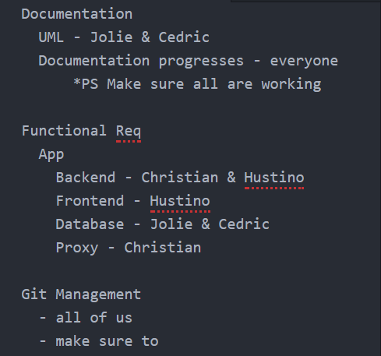

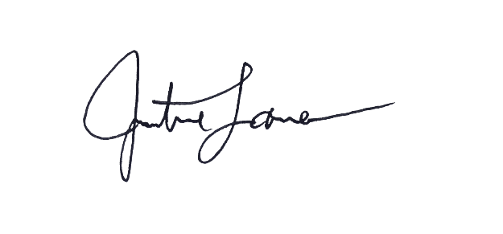

Figure 2.1

Justine Laserna

Person-in-charge